Vincennes University
American Sign Language & Deaf Studies Program
Blackboard
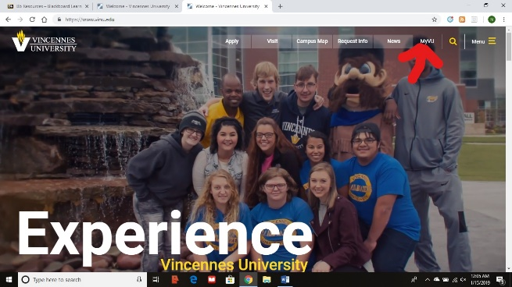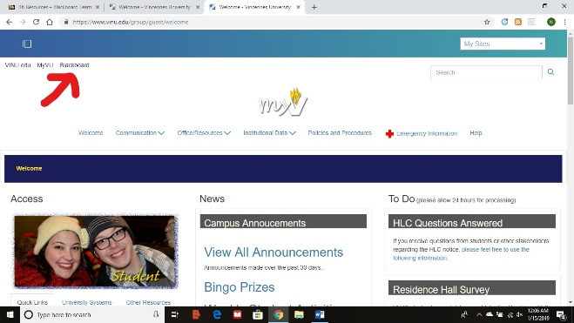
Login to Blackboard
Login to myVU
- Your name and a red number indicate if assignments have been graded.
- Click My Blackboard to return to this screen at any time.
- Any announcements from a teacher will show up here.
- Class listing. The order can be changed.
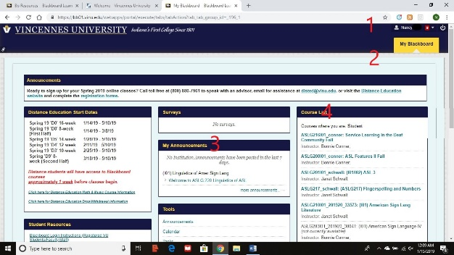

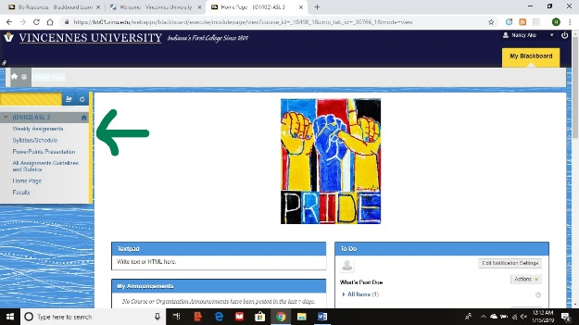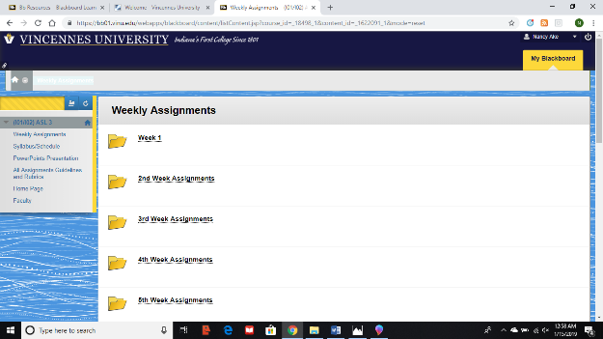
Click on the current week to see specific assignments.
Class info. Submit homework.

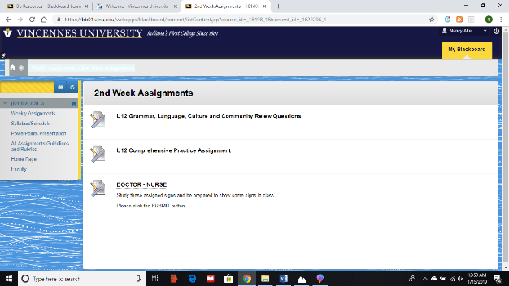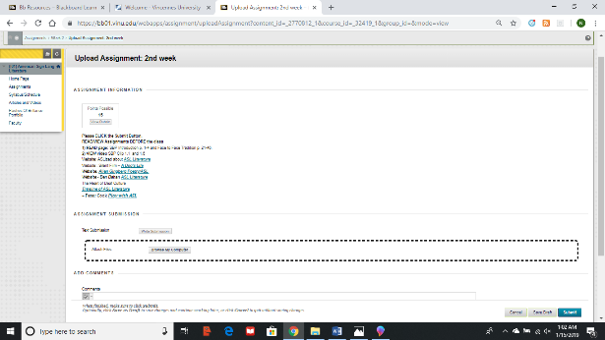
Type homework in a document program. Browse device to link homework. Click submit.
Click on the assignment to see details and to submit.
GoReact
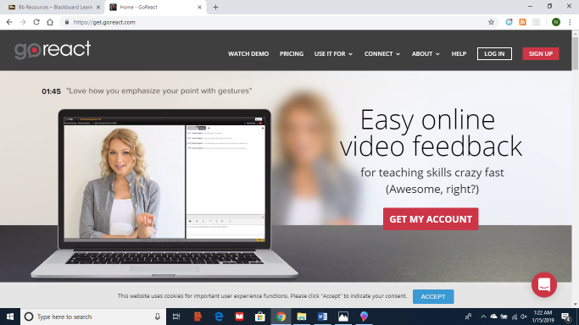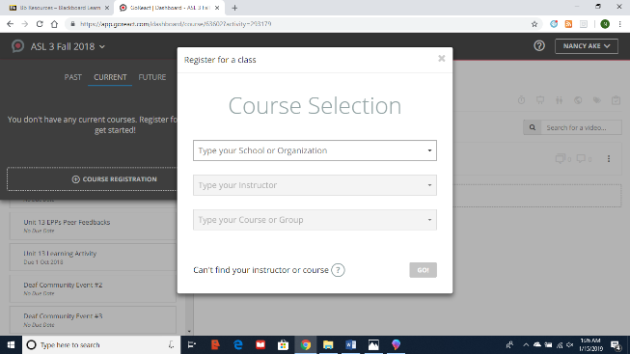

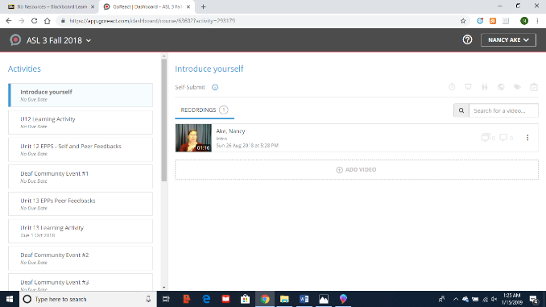

- Go to www.goreact.com
- Sign up or log in (top right-hand corner), depending if you’ve used it before. It is used in at least 5 classes at VU.
- Click on the arrow to the right of the GoReact symbol at the left-hand side of the screen to add a class. Enter requested information (school name, teacher name, course name) to enroll in the course.
- As assignments are due, select assignment, then Add Video. Videos can be added live or recorded and uploaded. DO NOT wait until 11:45 PM on the due date to record a video. Technology sometimes fails.
- Some assignments will require you to give feedback to peers. Selecting his/her video allows you to watch it and record feedback at the point you choose in his/her video. Teachers will determine if typed feedback or video feedback is needed.
iPad has an app to record videos and upload them. Video editing and feedback cannot be done through the app. The app does not always show the instructions for the video that are given within the web version.
Do have a good camera to make recordings. Teachers will explain what is needed to make a good video.

If you need help using the technology for classes, please ask the office assistants for help. The office assistants can help with a variety of student needs, or they can direct you to the best source for help.

